SQL CODES

KPI’S

1.SELECT SUM(QUANTITY*UNIT_PRICE) AS REVENUE FROM PIZZA_SALES



2. SELECT SUM(TOTAL_PRICE) / COUNT(DISTINCT ORDER_ID) AS AVERAGE_TOTAL_PRICE FROM PIZZA_SALES



3. SELECT SUM(QUANTITY) AS TOTAL_QUANTITY FROM pizza_sales



4. SELECT COUNT(DISTINCT ORDER_ID ) AS TOTAL_ORDERS FROM PIZZA_SALES

5. SELECT CAST(CAST(SUM(QUANTITY) AS DECIMAL(10,2)) / CAST(COUNT(DISTINCT ORDER_ID ) AS DECIMAL(10,2)) AS DECIMAL(10,2)) AS [AVERAGE TOTAL ORDERS] FROM pizza_sales

6. select datename(DW,order_DATE) AS ORDER_DAY, COUNT(DISTINCT ORDER_ID) AS TOTAL_ORDERS FROM PIZZA_SALES GROUP BY DATENAME ( DW,ORDER_DATE)

NOTE: DW refers to the day of the week, and datename just characterizes that date.

7. SELECT DATENAME (MONTH, ORDER_DATE) AS MONTH_NAME, COUNT (DISTINCT ORDER_ID) AS TOTAL_ORDERS FROM PIZZA_SALES GROUP BY DATENAME (MONTH, ORDER_DATE)

8. SELECT DATENAME(HOUR, ORDER_TIME) AS HOUR_NAME, COUNT(DISTINCT ORDER_ID) AS TOTAL_ORDERS FROM PIZZA_SALES GROUP BY DATENAME(HOUR,ORDER_TIME)

9.SELECT PIZZA_CATEGORY, SUM(TOTAL_PRICE)* 100 / (SELECT SUM(TOTAL_PRICE) FROM PIZZA_SALES) AS TOTAL_NUMBER_OF_SALES FROM PIZZA_SALES GROUP BY PIZZA_CATEGORY ORDER BY TOTAL_NUMBER_OF_SALES DESC

10. SELECT pizza_size, SUM(TOTAL_PRICE)* 100 / (SELECT SUM(TOTAL_PRICE) FROM PIZZA_SALES) AS TOTAL_NUMBER_OF_SALES FROM PIZZA_SALES

GROUP BY PIZZA_SIZE ORDER BY TOTAL_NUMBER_OF_SALES DESC

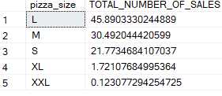

11.BOTTOM 5 PIZZAS BY TOTAL PRICE

SELECT TOP 5 PIZZA_NAME , CAST(SUM(TOTAL_PRICE) AS DECIMAL(10,2)) FROM PIZZA_SALES AS TOTAL_REVENUE GROUP BY PIZZA_NAME ORDER BY SUM(TOTAL_PRICE)

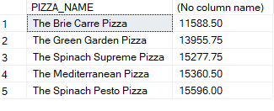

12. TOP 5 PIZZAS BY TOTAL PRICE

SELECT TOP 5 PIZZA_NAME, CAST(SUM(TOTAL_PRICE) AS DECIMAL(10,2)) FROM PIZZA_SALES AS TOTAL_REVENUE GROUP BY PIZZA_NAME ORDER BY SUM(TOTAL_PRICE)DESC

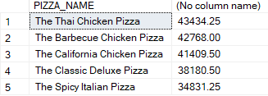

13. TOP 5 PIZZAS BY QUANTITY

SELECT TOP 5 PIZZA_NAME, SUM(QUANTITY) AS TOTAL_QUANTITY FROM PIZZA_SALES GROUP BY PIZZA_NAME ORDER BY SUM(QUANTITY)DESC

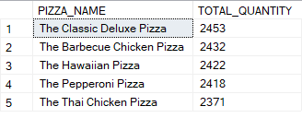

14. BOTTOM 5 PIZZAS BY QUANTITY

SELECT TOP 5 PIZZA_NAME, SUM(QUANTITY) AS TOTAL_QUANTITY FROM PIZZA_SALES GROUP BY PIZZA_NAME ORDER BY SUM(QUANTITY)ASC

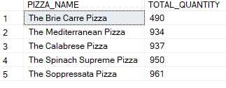

15. TOP 5 PIZZAS BY TOTAL ORDER

SELECT TOP 5 PIZZA_NAME, COUNT(DISTINCT ORDER_ID) AS TOTAL_ORDER FROM PIZZA_SALES GROUP BY PIZZA_NAME ORDER BY COUNT(DISTINCT ORDER_ID)DESC

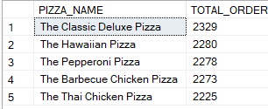

16. BOTTOM 5 PIZZAS BY TOTAL_ORDER

SELECT TOP 5 PIZZA_NAME, COUNT(DISTINCT ORDER_ID) AS TOTAL_ORDER FROM PIZZA_SALES GROUP BY PIZZA_NAME ORDER BY COUNT(DISTINCT ORDER_ID)